A Project Report On

**GameToh Food Ordering System**

Submitted in partial fulfillment of the requirement for the award of the degree

MASTER OF COMPUTER APPLICATIONS (INTEGRATED)

from

Gujarat Technological University



Academic Year 2020 – 2021

**Akash Trivedi (175220686001)**

|  |
| --- |
| **Internal Guide** |
| Prof. Vivek Gondalia |



Marwadi Education Foundation’s Group of Institutions

(MEFGI)

Rajkot-Morbi Road, At & PO: Gauridad, Rajkot 360003, Gujarat, India.



**Faculty of Computer Applications (FCA)**



**This is to certify that the project work entitled**

**GameToh Food Ordering System**

**submitted in partial fulfillment of the requirement for**

**the award of the degree of**

**Master of Computer Applications (Integrated)**

**of the**

**Gujarat Technological University**

**is a result of the bonafide work carried out by**

**Akash Trivedi (175220686001)**

**during the academic year 2020 - 2021**

|  |  |  |  |  |
| --- | --- | --- | --- | --- |
| **Faculty Guide** |  |  |  | **HOD** |

**External Viva**

|  |  |  |
| --- | --- | --- |
| **Name of the Examiners** |  | **Signature with Date** |

# DECLARATION

I hereby declare that this project work entitled **GameToh Food Ordering System** is a record done by me.

I also declare that the matter embodied in this project is genuine work done by me and has not been submitted whether to this University or to any other University / Institute for the fulfillment of the requirement of any course of study.

Place:

Date:

Akash Trivedi (175220686001) **Signature: _________**

# ACKNOWLEDGEMENT

It is indeed a great pleasure to express a thanks and gratitude to all those who helped me. No serious and lasting achievement or success one can ever achieve without the help of friendly guidance and co-operation of so many people involved in the work.

I am very thankful to our guide Prof. Vivek Gondalia for his insightful direction**. T**he person who makes me to follow the right steps during a project work. I express my deep sense of gratitude to him for his guidance, suggestions and expertise at every stage. A part from that his valuable and expertise suggestion during documentation of my report indeed help me a lot.

Thanks to our friends and colleagues who have been a source of inspiration and motivation that helped to us with new ideas during our project work.

I would heartily thankful to Head and Dean of our department **Dr. Sunil Bajeja and Dr. R. Sridaran** to give me an opportunity to work over this report and for their end-less and great support. And to all other people who directly or indirectly supported and help me to fulfil this task.

Akash Trivedi (175220686001) **Signature: _________**

# Table of Contents

|  |  |  |
| --- | --- | --- |
| **Chapters** | **Particulars** | **Page No.** |
| 1 | **SYNOPSIS** | 1 |
| 2 | **PREAMBLE**  Modules and Description | 2 |
| 3  3.1  3.2 | **TECHNICAL DESCRIPTION**  Hardware Requirement  Software Requirement | 3 |
| 4 | **SYSTEM DESIGN AND DEVELOPMENT** | 4 |
| 5 | **SYSTEM TESTING** | 11 |
| 6 | **SCREEN SHOTS** | 12 |
| 7 | **SOURCE CODE** | 17 |
| 8 | **CONCLUSION** | 23 |
| 9  9.1  9.2 | **BIBLIOGRAPHY**  Online References  Offline References | 24 |

# FIGURE INDEX

|  |  |  |  |
| --- | --- | --- | --- |
| **Sr. No.** | **Figure No.** | **Particulars** | **Page No.** |
| 1 | 4.1 | Use Case | 4-6 |
| 2 | 4.2 | Activity | 7 |
| 3 | 4.3 | Class Diagram | 8 |
| 4 | 4.4 | Interaction Diagram | 9 |
| 5 | 4.5 | Data dictionary | 10 |

# TABLE INDEX

|  |  |  |  |
| --- | --- | --- | --- |
| **Sr. No.** | **Table No.** | **Particulars** | **Page No.** |
| 1 | 3.1 | Hardware Requirements | 3 |
| 2 | 3.2 | Software Requirements | 3 |
| 3 | 5.1 | Login | 11 |
| 4 | 5.2 | Homepage | 11 |
| 5 | 5.3 | Admin Controls | 11 |

# Synopsis

The aim of developing GameToh Food services project is to replace the traditional way, of taking orders, with computerized system. Another important reason for developing this project is to digitize the summary reports and user-friendly format at any point of time when needed.

GameToh Food services is a part of ecommerce through which we can carry-out selling, distributing, marketing for the outlet owner also providing Service over internet to remote public.

Also, for building a Food Service website we need to upload variety of cuisine online to attract potential and diverse customers. The GameToh food services gives restaurant the ability to increase sales and expand their business by giving customers the facility to order food online. With an online restaurant menu service, the customer can place orders online 24x7. Thus, it is a simple, fast and convenient food services giving an edge over the competition at an affordable price.

Internet has experienced a tremendous growth in terms of coverage and awareness. So, giving the business an online presence has become very crucial and advantageous. With GameToh Food Services, we can set up restaurant menu online and the customers can easily place order with a simple mouse click/tap. Also, with an online service we can easily track the orders, maintain customer's database and improve our food delivery service.

Customers can order food directly over internet. The restaurants can even customize online restaurant menu and upload images easily. Having restaurant menu over internet, potential customers can easily access it and place order at their convenience venue.

Also, these days women are no less than men, in any field, so, in big cities even wives are working women, therefore mostly the small families manage to have food order from somewhere as they lack time, so this service will be of great help to them also.

# Preamble

This project is developed in order to help the people so they can reach food services 24/7, no need to go to the restaurant to buy the food. This increases the convenience for customers for food any time. Through our website customers can easily view the menu of their own choice’s cuisine and can easily order/book them to eat according to their convenience.

Through our service the people can order their favorite food from remote location any time. By using this kind of service owner/customer/organization can easily track the order details, destination time and weekly cost percentage.

Customer can also provide feedback about the quality of food and delivery services, thus helping the food outlet/restaurant get better in delivering the services and improving the food quality. This will help the organization to grow further and provide better service.

## Modules and Description

1. Admin
2. Manager
3. Customer

## Admin

* + Admin will verify the details of restaurant, provided by the restaurant manager, at the time of registering.
  + Admin will also add gift coupons/deals on special days.
  + Admin will also review the feedback from the customers and pass them to the respected restaurant.
  + Admin can also review the activity of suspected customers and if applicable can also suspend the account for some period of time.

## Manager

* Manager requests the admin to add their restaurant with our web service.
* Manager adds items, deletes items.

## Customer

* Customer logins/signup to place an order.
* Customer goes through the food items of his/her choice from the menu.
* Customer also gets the facility of multi cuisine to choose from.
* Customer can also avail the benefits of the coupons.
* Customer gives the feedback of the food service provided to him/her by that restaurant.

# Technical Description

## Hardware Requirement

|  |  |
| --- | --- |
| **Requirements** | **Quantity** |
| Ram | 2GB or more |
| Processor | Intel i3 or more |
| Storage required | HDD 10Gb |

**Table 3.1**

## Software Requirement

|  |  |
| --- | --- |
| OS | Microsoft Windows 7 or more |
| Browser | Mozilla Firefox / Google Chrome / Microsoft Edge |
| Editor | Visual Studio Code |
| Versions | PHP 7.3.1, phpMyAdmin 4.9.1, Apache 2.4.41 |

**Table 3.2**

# System Design and Development

## Use Case Diagram

### Customer

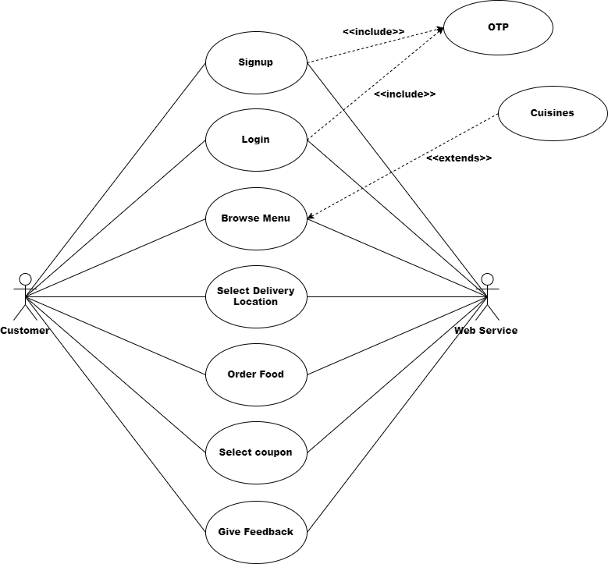

### Admin

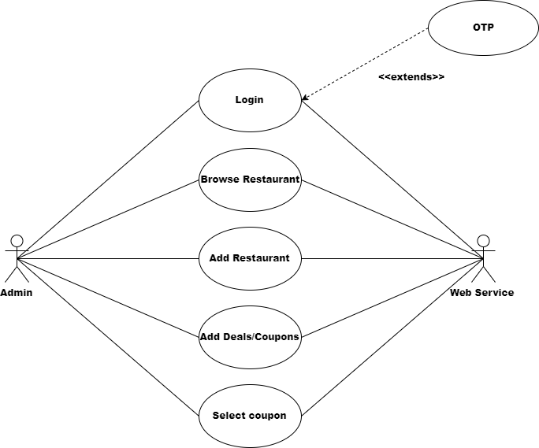

### Manager

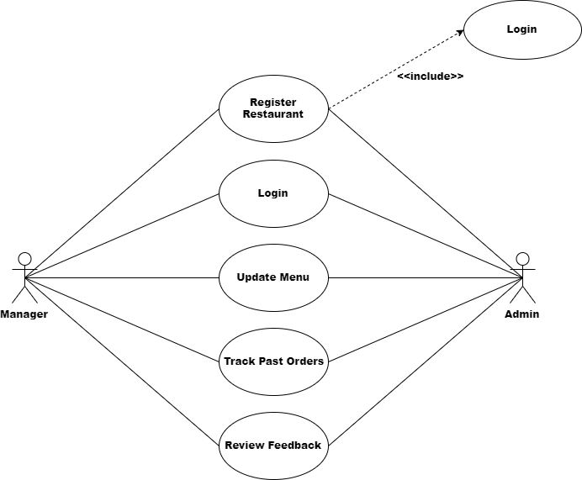

## Activity Diagram

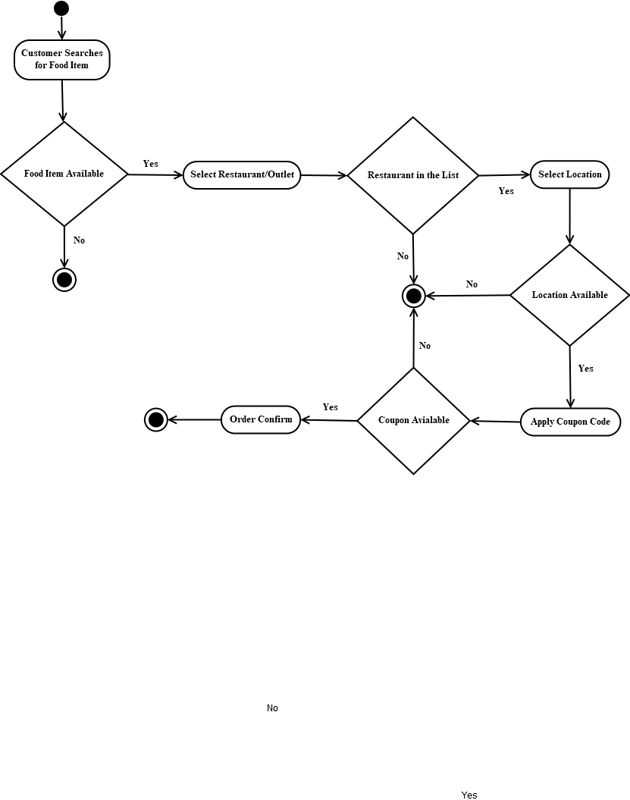

## Class Diagram

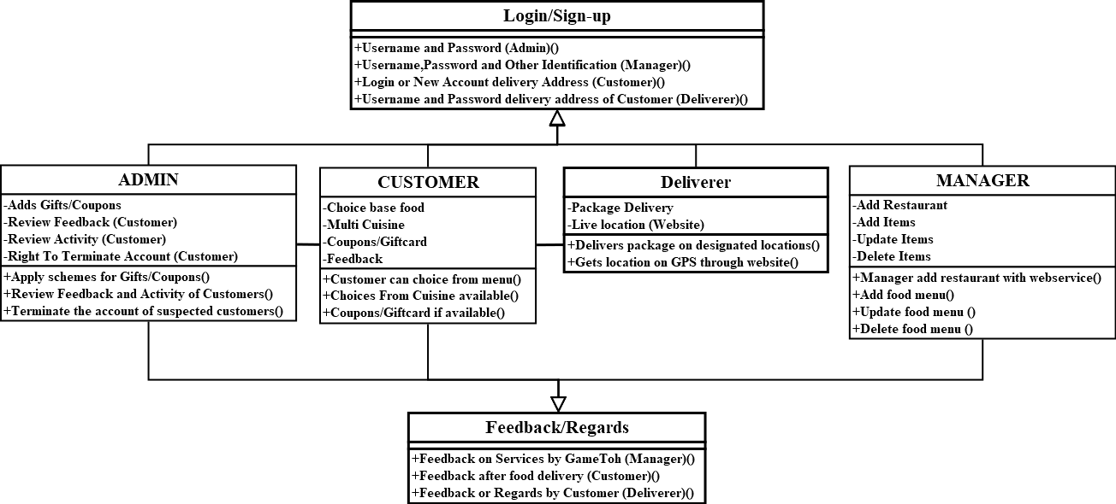

## Interaction Diagram

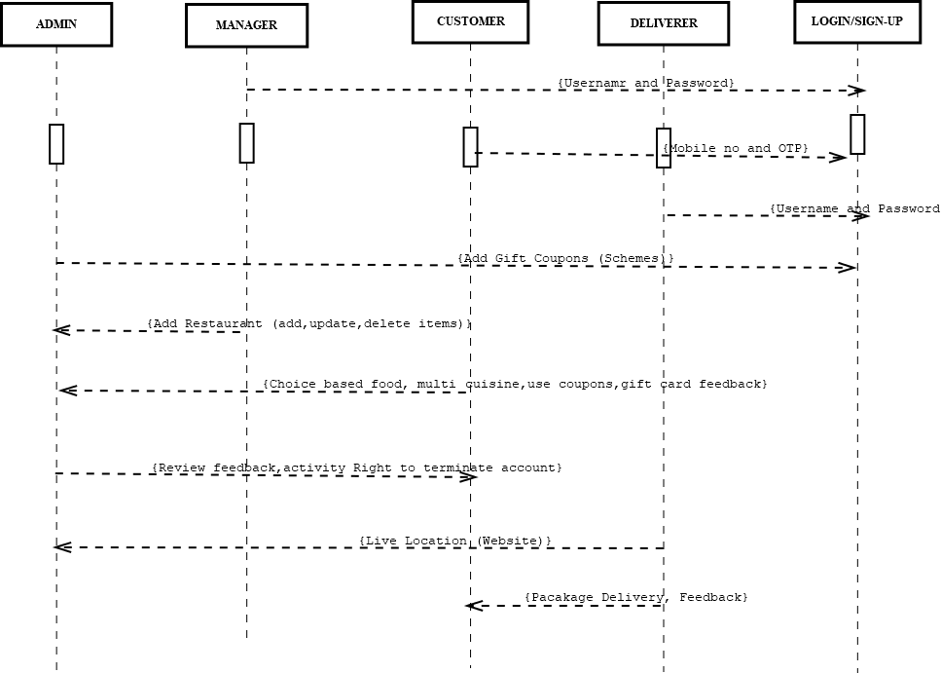

## Data Dictionary Diagram

### Customer Data Dictionary Diagram:

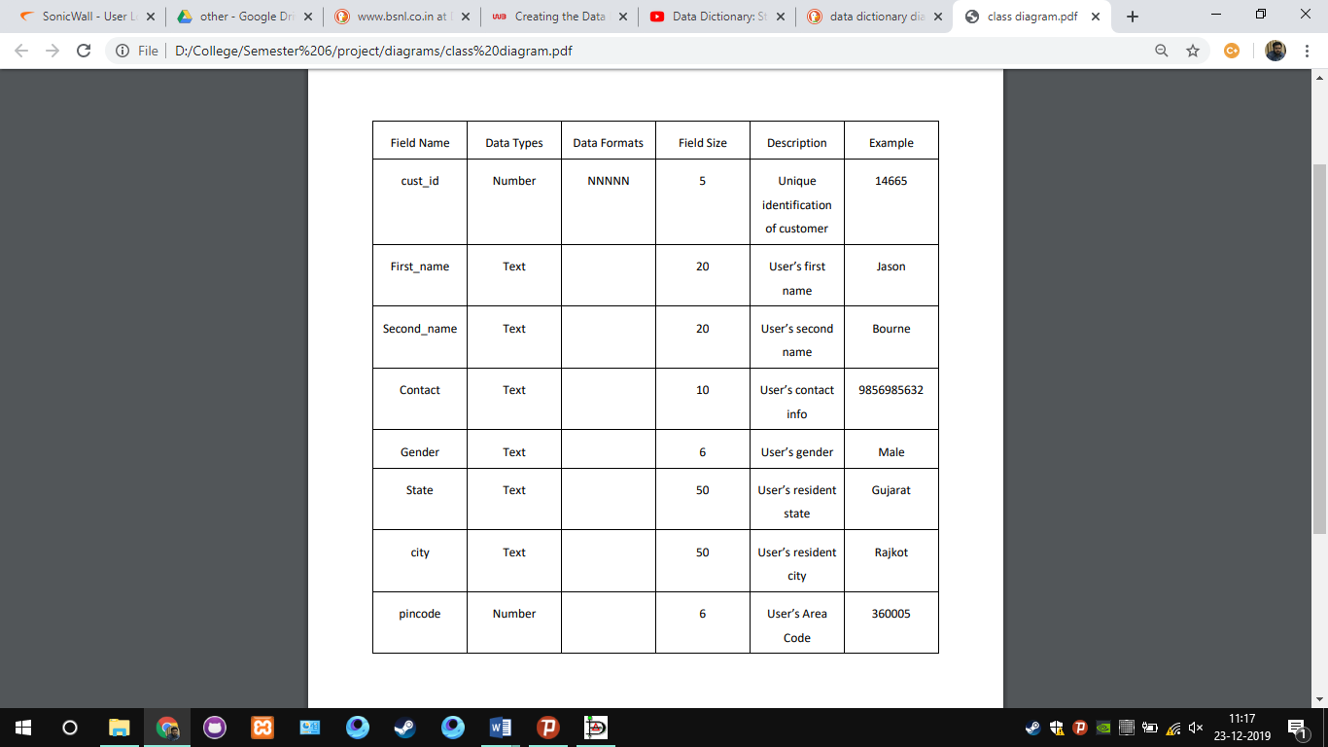

### Restaurant Data Dictionary Diagram

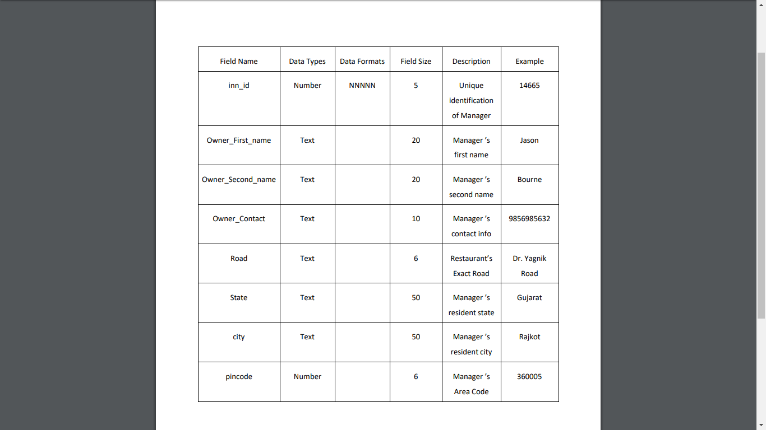

# System Testing

## Login

|  |  |
| --- | --- |
| **Page** | Login |
| **Description** | It is a common login page which lets user enter in |
| **Input** | Username and Password |
| **Output** | Successful Login |

## Homepage

|  |  |
| --- | --- |
| **Page** | Homepage |
| **Description** | Users can view hotels and place their food order |
| **Input** | Select food items from menu available |
| **Output** | Placing Order |

## Admin Controls

|  |  |
| --- | --- |
| **Page** | Admin Login |
| **Description** | System admin can view restaurants, verify new ones, view customers, view monthly sales etc. |
| **Input** | Admin credentials |
| **Output** | Admin Dashboard |

# Screenshots

## List new restaurant on the website

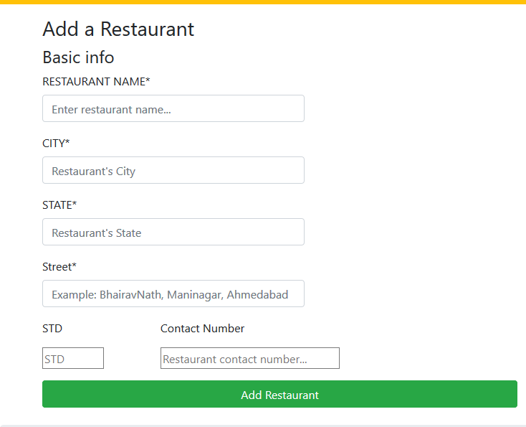

## Customer Login and Search Restaurants

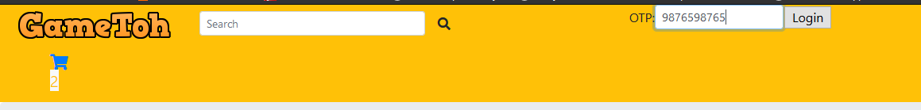

## Add to cart

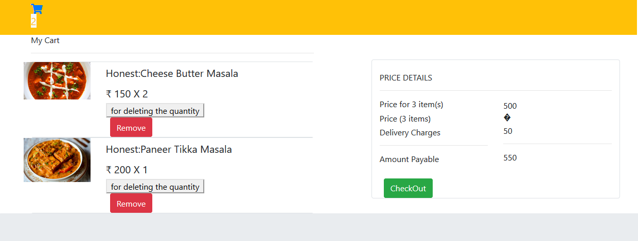

## Checkout

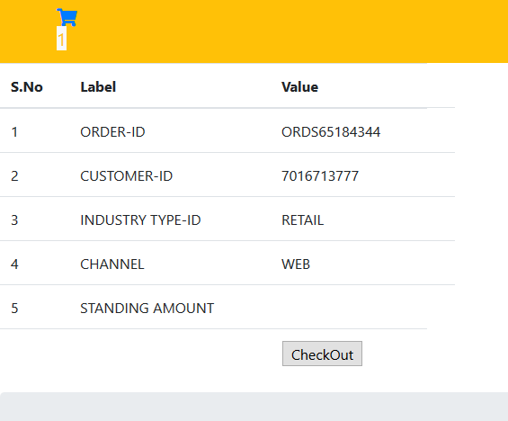

## Redirecting to payment

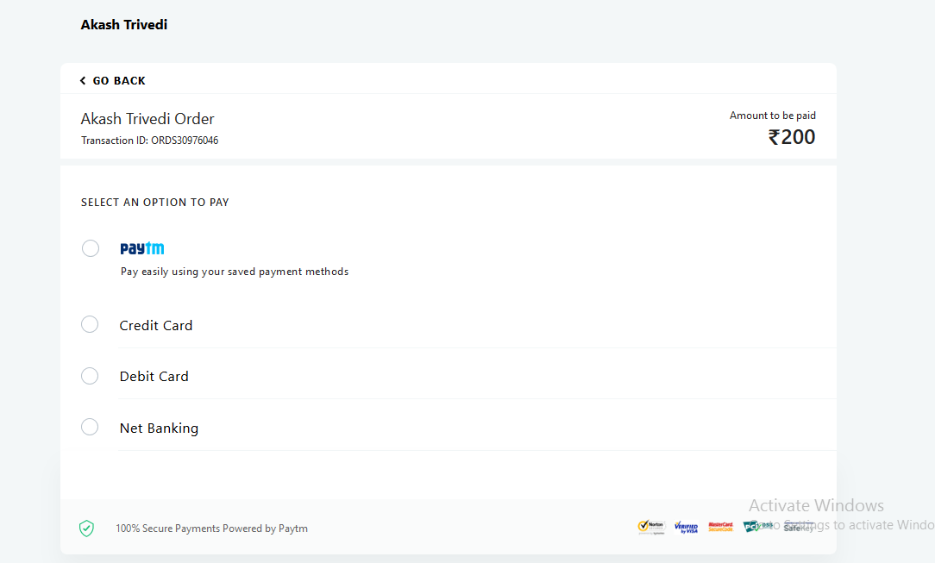

## Admin Side

### Admin Login



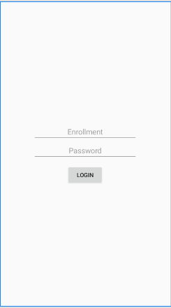

## Monthly Sales

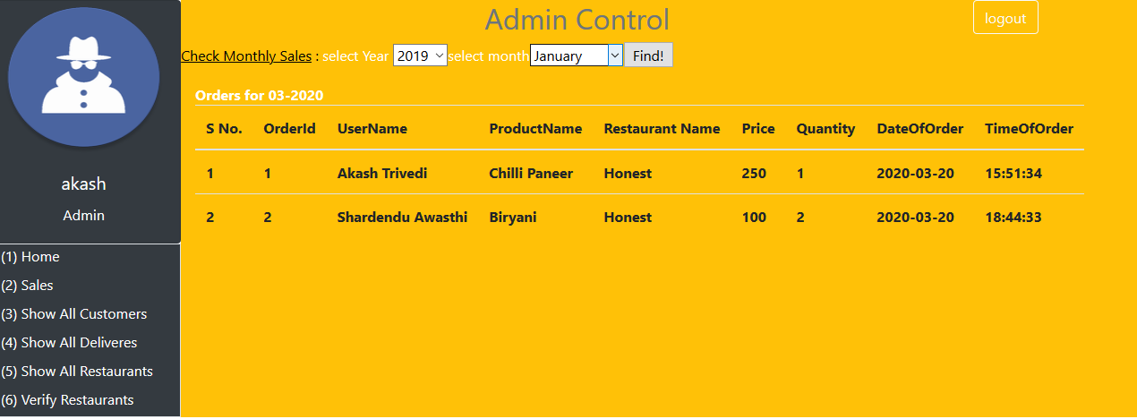

### List customers

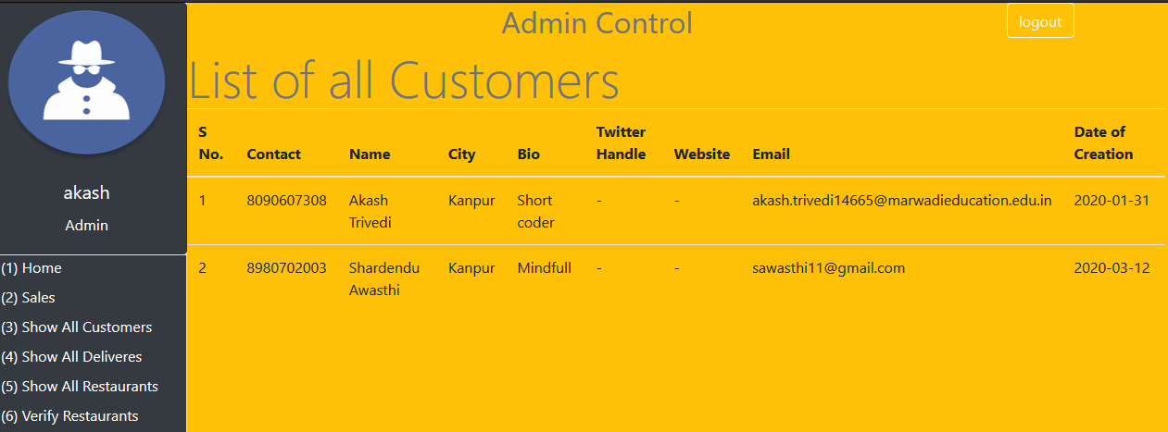

### List restaurants

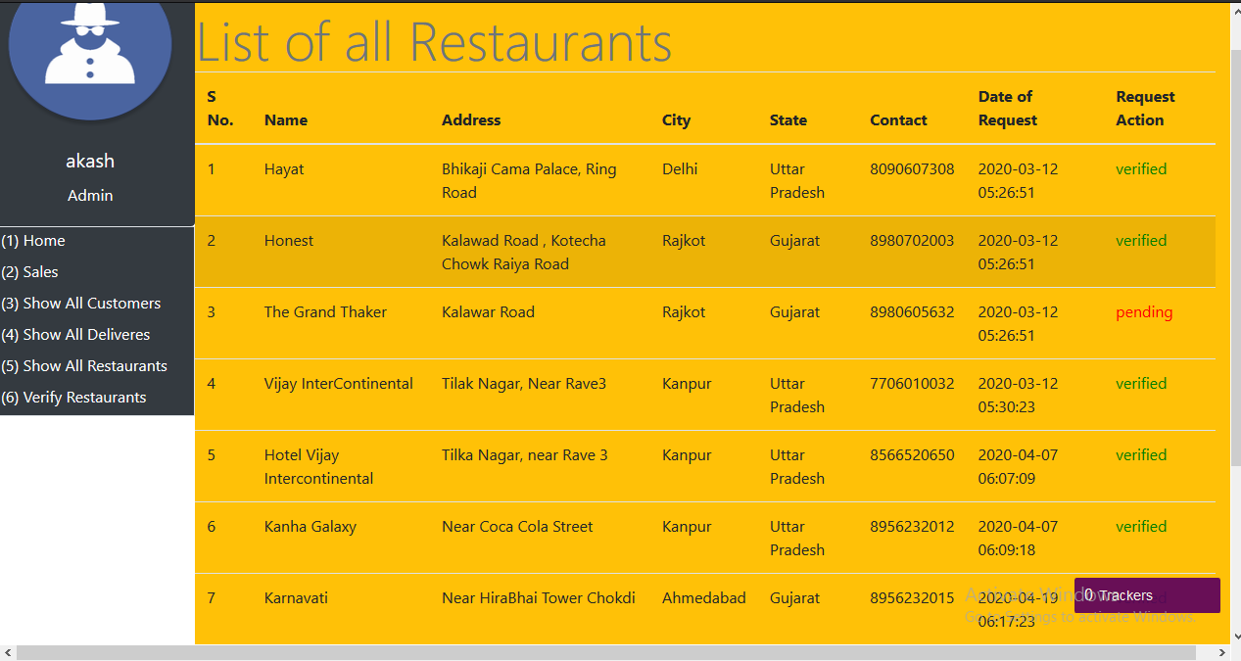

### Verify new restaurants

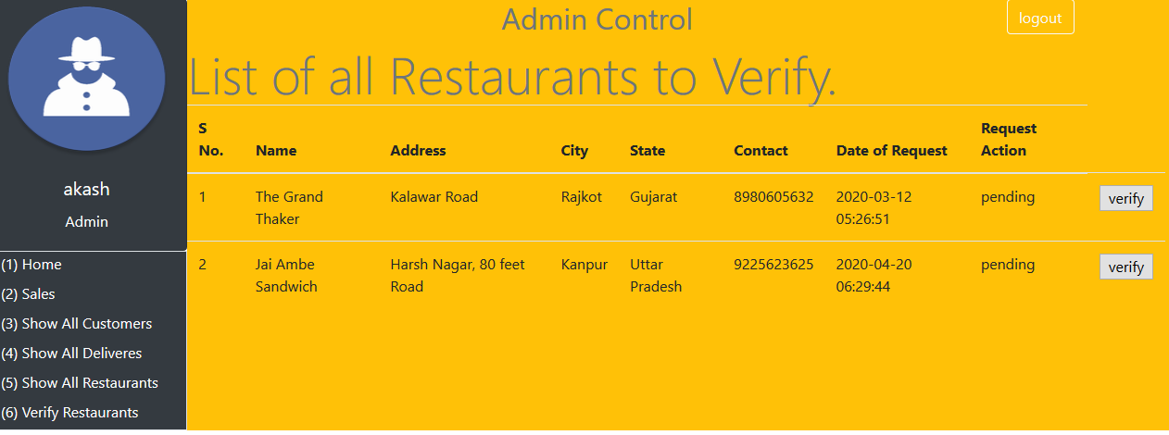

# Source-Code

## PHP

### Head.php

<!DOCTYPE html>

<html lang="en">

<head>

<meta charset="UTF-8">

<meta name="viewport" content="width=device-width, initial-scale=1.0">

<meta http-equiv="X-UA-Compatible" content="ie=edge">

<link rel="stylesheet" href="https://cdnjs.cloudflare.com/ajax/libs/font-awesome/5.8.2/css/all.css" />

<link rel="stylesheet" href="https://stackpath.bootstrapcdn.com/bootstrap/4.4.1/css/bootstrap.min.css" integrity="sha384-Vkoo8x4CGsO3+Hhxv8T/Q5PaXtkKtu6ug5TOeNV6gBiFeWPGFN9MuhOf23Q9Ifjh" crossorigin="anonymous">

<script src="https://code.jquery.com/jquery-3.3.1.slim.min.js" integrity="sha384-q8i/X+965DzO0rT7abK41JStQIAqVgRVzpbzo5smXKp4YfRvH+8abtTE1Pi6jizo" crossorigin="anonymous"></script>

<script src="https://cdnjs.cloudflare.com/ajax/libs/popper.js/1.14.3/umd/popper.min.js" integrity="sha384-ZMP7rVo3mIykV+2+9J3UJ46jBk0WLaUAdn689aCwoqbBJiSnjAK/l8WvCWPIPm49" crossorigin="anonymous"></script>

<script src="https://stackpath.bootstrapcdn.com/bootstrap/4.1.3/js/bootstrap.min.js" integrity="sha384-ChfqqxuZUCnJSK3+MXmPNIyE6ZbWh2IMqE241rYiqJxyMiZ6OW/JmZQ5stwEULTy" crossorigin="anonymous"></script>

<title>Homepage</title>

</head>

<body>

<header>

<div class="row page-header bg-warning container-fluid">

<div class="col-sm-2"><a href="index.php"><img src="image/logo.png" alt="altimg"></a></div>

<div class="col-sm-4 searchbox"><!--search bar-->

<form action="<?=base_url().'index.php/Welcome/search' ?>" method="POST" class="form-inline d-flex justify-content-center md-form form-sm active-purple-2 mt-2">

<input class="form-control form-control-sm mr-3 w-75" type="text" placeholder="Search" name="item"

aria-label="Search" autocomplete="off"><i class="fas fa-search" aria-hidden="true"></i>

</form>

</div>

<div class="col-sm-6 bg-warning">

<?php

if(!isset($_SESSION['user'])){//when not logged in.

loginForm();

} else{//when logged in.

userLog();

}

?>

</div>

<?php

if(isset($_SESSION['cart'])){

echo '<div style="display: inline-block;" class="col-sm-1 bg-warning" id="navbarNavAltMarkup"><!--My Cart-->

<div class="mr-auto"></div>

<div class="navbar-nav">

<a href="cart.php" class="nav-item nav-link active">

<h5 class="px-5 cart">

<i class="fas fa-shopping-cart"></i>';

$count = count($_SESSION['cart']);

echo '<span id="cart_count" class="text-warning bg-light">'.$count.'</span>';

echo '

</h5>

</a>

</div>

</div>';

} else{

$count=0;

} ?>

</div>

<script type="text/javascript">

if((document.getElementById('cart_count')).innerHTML==0){

(document.getElementById('navbarNavAltMarkup')).style.display="none";

}

</script>

</header>

### Welcome.php

<?php

defined('BASEPATH') OR exit('No direct script access allowed');

class Welcome extends CI_Controller {

public function divert($page=''){

$page= substr($page, 0, strpos($page, '.'));

$this->load->view($page);

}

public function index(){

$this->load->model('Foot');

$links= $this->Foot->getLinks();

$this->load->view('template/head');

$this->load->view('homepage');

$this->load->view('template/foot', $links);

}

public function search($query=''){

$this->load->view('food');

}

}

### Cart.php

<?php

const TITLE="My Cart";

require_once('head.php');

?>

<!--THE MAIN CART COLUMN-->

<div class="container-fluid">

<div class="row px-5">

<div class="col-md-6">

<?php

$total = 0;

if (isset($_SESSION['cart']) and count($_SESSION['cart'])>0){

echo '<div class="shopping-cart">

<h6>My Cart</h6>

<hr>';

$count=0;

foreach ($_SESSION['cart'] as $key=>$value){

$id=$value['productId'];

$rid=$value['restaurantId'];

$query="SELECT * FROM menu NATURAL JOIN restaurants WHERE itemId='$id' AND restaurantId='$rid'";

$result=mysqli_query($_SESSION['db']->conobj, $query);

$data=mysqli_fetch_array($result, MYSQLI_ASSOC);//bool given means Query result false

cartElement($data['photo'], $data['nm'].":".$data['itemName'], $data['price'], $data['itemId'], $data['restaurantId'], $value['count']);

$total+=$data['price']*$value['count'];

}

echo '</div>';

echo '</div>';

sideBill($total);

echo '</div>

</div>

</div>

</div>';

} else{

echo "<h5>Cart is Empty. <a href='food.php'>Browse</a></h5>";

}

?>

### Checkout.php

<?php

const TITLE="CheckOut";

?>

<div class="check-out form row">

<div class="col-sm-5">

<form method="post" action="paytm/PaytmKit/pgRedirect.php">

<table class="table table-hover">

<thead>

<tr>

<th>S.No</th><th>Label</th><th>Value</th>

</tr>

</thead>

<tbody>

<tr>

<td>1</td>

<td>ORDER-ID</td>

<td><?php echo "ORDS" . rand(10000,99999999)?></td>

<td><input type="hidden" id="ORDER_ID" tabindex="1" maxlength="20" size="20"

name="ORDER_ID" autocomplete="off"

value="<?php echo "ORDS" . rand(10000,99999999)?>">

</td>

</tr>

<tr>

<td>2</td>

<td>CUSTOMER-ID</td>

<td><?php print_r($_SESSION['contact'])?></td>

<td><input type="hidden" id="CUST_ID" tabindex="2" maxlength="12" size="12" name="CUST_ID" autocomplete="off" value="CUST001"></td>

</tr>

<tr>

<td>3</td>

<td>INDUSTRY TYPE-ID</td>

<td>RETAIL</td>

<td><input type="hidden" id="INDUSTRY_TYPE_ID" tabindex="4" maxlength="12" size="12" name="INDUSTRY_TYPE_ID" autocomplete="off" value="Retail"></td>

</tr>

<tr>

<td>4</td>

<td>CHANNEL</td>

<td>WEB</td>

<td><input type="hidden" id="CHANNEL_ID" tabindex="4" maxlength="12"

size="12" name="CHANNEL_ID" autocomplete="off" value="WEB">

</td>

</tr>

<tr>

<td>5</td>

<td>STANDING AMOUNT</td>

<td><?php $_POST['amount']?></td>

<td><input title="TXN_AMOUNT" tabindex="10"

type="hidden" name="TXN_AMOUNT"

value="<?php echo $_POST['amount']?>">

</td>

</tr>

<tr>

<td></td>

<td></td>

<td><input value="CheckOut" type="submit" onclick=""></td>

</tr>

</tbody>

</table>

</form>

</div>

</div>

### Functions.php

<?php

function searchItem($id, $rid){

foreach($_SESSION['cart'] as $key=>$value){

if($value['productId']==$id && $value['restaurantId']==$rid){

return $key;

}

}

return -1;

}

function getArray($table, &$profile){

global $dbobj1;

$query="SELECT * FROM userPrivilages WHERE 1";

$result=mysqli_query($_SESSION['db']->conobj, $query);

return mysqli_fetch_array($result, MYSQLI_ASSOC);

}

function printMenu($id, $rid, $name, $image, $price, $rnm, $addr){

$menu='

<form action="#" method="POST">

<div class="row container"><!--individual container-->

<div class="row border border-bottom-danger rounded container"><!--first row-->

<div class="col-sm-4"><img src="../'.$image.'" style="width: 200px; height: 200px;"></div>

<div class="col-sm-6">

<div class="row"><h6>'.$rnm.'</h6></div>

<div class="row"><div class="text-danger text-capitalize h3 font-weight-bolder">'.$rnm.'</div></div>

<div class="row"><h6>STREET</h6></div>

<div class="row"><h6>'.$addr.'</h6></div>

</div>

<div class="col-sm-2"><h6>RATING VOTE COUNT</h6></div>

</div>

<div class="row container"><!--first row over & second row-->

<div class="col-md-4 text-secondary text-">CUISINES:</div>

<div class="col-md-8"><h6>'.$name.'</h6></div>

</div><!--second row over and third row starts-->

<div class="row container">

<div class="col-sm-4 text-secondary"><h6>COST FOR TWO:</h6></div>

<div class="col-sm-8"><h6>'.$price.'</h6></div>

</div><!--third row over and fourth row starts-->

<div class="row container">

<div class="col-sm-4 text-secondary"><h6>HOURS:</h6></div>

<div class="col-sm-8"><h6>11am-11:30pm (Mon-Sun)</h6></div>

</div>

<div class="row container border border-bottom dark text-center">

<div class="col p-3 border border-dark"><h6><i class="fa fa-phone" aria-hidden="true"></i> Call</h6></div>

<div class="col p-3 border border-dark"><h6><i class="fa fa-list" aria-hidden="true"></i> View-menu</h6></div>

<input type="hidden" name="productId" value="'.$id.'">

<input type="hidden" name="restaurantId" value="'.$rid.'">

<button type="submit" class="btn btn-warning my-3" name="add">Add to Cart <i class="fas fa-shopping-cart"></i></button>

</div>

</div><!--individual container ends--></form>';

echo $menu;

}

function loginForm(){

echo '<form action="send_otp/sendotp.php" method="POST">';

if(isset($_SESSION['otp'])){

echo 'OTP for '.$_SESSION["contact"];

echo '<label for="otp"> OTP: </label><input type="text" id="otp" name="otp">';

echo '<input type="submit" value="Login" name="cnfotp">';

} else{

echo '<label for="contact">Contact No.: </label><input type="text" id="contact" name="contact">';

echo '<input type="submit" value="Send OTP" name="sendotp">';

}

echo '</form>';

}

function addToCart($id, $rid){

if(isset($_SESSION['cart'])){

$key=searchItem($id, $rid);

if($key==-1){//if use false then error, beacuse we cannot print or use false.

$item_array = array(

'productId'=>$id,

'restaurantId'=>$rid,

'count'=>1

);

$count=sizeof($_SESSION['cart']);

$_SESSION['cart'][$count]=$item_array;

} else{

$_SESSION['cart'][$key]['count']+=1;

unset($key);

header("Location: index.php");

}

} else{

$item_array = array(

'productId'=>$id,

'restaurantId'=>$rid,

'count'=>1

);

$_SESSION['cart'][0]=$item_array;

}

return TRUE;

}

function removeFromCart($id, $rid){

if(isset($_SESSION['cart'])){

$key=searchItem($id, $rid);

if($key!=FALSE){

unset($_SESSION['cart']);

}

} else{

unset($_SESSION['cart']);

header("Location: cart.php");

}

}

function cartElement($productimg, $productname, $productprice, $productid, $restaurantId, $productcount){

$element = "

<form action=\"cart.php?action=remove&id=$productid\" method=\"post\" class=\"cart-items\">

<div class=\"border rounded\">

<div class=\"row bg-white\">

<div class=\"col-md-3 pl-0\">

<img src=$productimg alt=\"$productimg\" class=\"img-fluid\">

</div>

<div class=\"col-md-6\">

<h5 class=\"pt-2\">$productname</h5>

<h5 class=\"pt-2\">&#x20b9 $productprice X $productcount</h5>

<button type=\"submit\" class=\"btn btn-danger mx-2\" name=\"remove\">Remove</button>

<input type='hidden' name='productId' value='$productid'>

<input type='hidden' name='restaurantId' value='$restaurantId'>

</div>

</div>

</div>

</form>

";

echo $element;

}

function userLog(){

echo '

<div class="dropdown">

<button class="btn btn-secondary dropdown-toggle pull-right" type="button" id="dropdownMenuButton" data-toggle="dropdown" aria-haspopup="true" aria-expanded="false">

<div class="card link right" style="width: 8rem;"></div>

</button>

<div class="dropdown-menu" aria-labelledby="dropdownMenuButton">';

$table='userPrivilages';

$query="SELECT * FROM userPrivilages WHERE 1";

$result=mysqli_query($_SESSION['db']->conobj, $query);

while($profile=mysqli_fetch_array($result)){

echo "<a class=\"dropdown-item\" href=\"".$profile['link']."\">".$profile['name']."</a>";

}

echo '</div></div>';

}

function searchFood($item){

$product=strtolower($item);

$query="SELECT * FROM menu NATURAL JOIN restaurants WHERE TRUE";

$result=mysqli_query($_SESSION['db']->conobj, $query);

$array=mysqli_fetch_all($result, MYSQLI_ASSOC);//(Procedural Style)Every row is now transfered as array in $array

if(count($array)>0){

$count=0;

$index=0;

foreach ($array as $data){

//To Check if the Data was Found or Not(searching comapny/full product name wise)

if(strtolower($data['itemName'])==$product || strtolower($data['nm'])==$product || stristr(($data['itemName']),$product) || stristr(($data['nm']),$product) ){

$_SESSION['search'][$index]=$data;

$index++;

}else{

$count+=1;

}

}

if($count==count($array)){

return -1;

echo "<h1 style='text-align:center;color=red;'>Oops1 No Such Product Available Yet!:(</h1>";

}

} else{

?>

<h1 style="text-align:center;color=red;">Oops2 No Such Product Available Yet!:(</h1><?php

}

}

## JAVA

### MainAcitivty.java

**package** com.ak.gametoh;  
  
**import** androidx.appcompat.app.AppCompatActivity;  
**import** android.content.Intent;  
**import** android.content.SharedPreferences;  
**import** android.content.SharedPreferences.Editor;  
**import** android.database.Cursor;  
**import** android.database.sqlite.SQLiteDatabase;  
**import** android.os.Bundle;  
**import** android.view.View;  
**import** android.widget.EditText;  
**import** android.widget.Button;  
**import** com.ak.myerp.data.StudentHelper;  
  
**public class** MainActivity **extends** AppCompatActivity **implements** View.OnClickListener {  
 **private** SharedPreferences **sp**;  
 **private** SharedPreferences.Editor **spe**;  
 **private** SQLiteDatabase **db**;  
 **private** EditText **userId**, **password**;  
 **private** Button **login**;  
 @Override  
 **protected void** onCreate(Bundle savedInstanceState) {  
 *//* ***TODO: 11-11-2020 initiate network thread for constant check of the internet*** *//* ***TODO: 11-11-2020 check active sessions* super**.onCreate(savedInstanceState);  
 setContentView(R.layout.***activity_main***);  
 {  
*// PARSING* **userId**= findViewById(R.id.***uid***);  
 **password**= findViewById(R.id.***pswd***);  
 **login**=findViewById(R.id.***login***);  
 **login**.setOnClickListener(**this**);  
 }  
 {  
*// check if the session is active then load the data  
// if not then load the shared preferences file for faster login* **sp**= getPreferences(***MODE_WORLD_READABLE***);  
 **spe**= **sp**.edit();  
*// LOADING DATABASE* AdminHelper sh= **new** Helper(**this**);  
 **db**= sh.getReadableDatabase();  
 }  
 }  
  
 @Override  
 **public void** onClick(View view){  
 **boolean** notFound= **false**;  
 String result= **sp**.getString(**"ennum"**, **userId**.getText().toString());  
   
 Cursor data;  
 *//* ***TODO: 10-11-2020 check credentials from the localhost network having the sql server turned on.*** *//* ***TODO: 10-11-2020 if true then transfer to next view the main menu for the admin.*** String[] Projection={  
 **""** };  
*// data= db.query("student");* Intent admin= **new** Intent(**this**, Admin.**class**);  
 **this**.startActivity(admin);  
 }  
}

### RestaurantHelper.java

**package** com.ak.gametoh.data;  
  
**import** android.content.Context;  
**import** android.database.sqlite.SQLiteDatabase;  
**import** android.database.sqlite.SQLiteOpenHelper;  
**import static** com.ak.myerp.data.RestaurantContract.***DATABASE_NAME***;  
**import static** com.ak.myerp.data.RestaurantContract.***DATABASE_VERSION***;  
**import static** com.ak.myerp.data.StudentContract.StudentEntry.***QUERY_CREATE_TABLE***;  
  
**public class** RestaurantHelper **extends** SQLiteOpenHelper {  
  
 **public** RestaurantHelper(Context context) {  
 **super**(context, ***DATABASE_NAME***,**null**, ***DATABASE_VERSION***);  
 }  
  
 @Override  
 **public void** onCreate(SQLiteDatabase db){  
 db.execSQL(***QUERY_CREATE_TABLE***);  
 }  
  
 @Override  
 **public void** onUpgrade(SQLiteDatabase db, **int** oldVersion, **int** newVersion){  
  
 }  
}

## XML

### Activity_main.xml

*<?***xml version="1.0" encoding="utf-8"***?>*<**LinearLayout xmlns:android="http://schemas.android.com/apk/res/android"  
 xmlns:app="http://schemas.android.com/apk/res-auto"  
 xmlns:tools="http://schemas.android.com/tools"  
 android:layout_width="match_parent"  
 android:layout_height="match_parent"  
 android:orientation="vertical"  
 android:padding="80dp"  
 tools:context=".MainActivity"  
 android:gravity="center"**>  
 <**EditText  
 android:layout_width="match_parent"  
 android:layout_height="wrap_content"  
 android:id="@+id/uid"  
 android:inputType="number"  
 android:gravity="center"  
 android:hint="Enrollment"**/>  
 <**EditText  
 android:layout_width="match_parent"  
 android:layout_height="wrap_content"  
 android:id="@+id/pswd"  
 android:gravity="center"  
 android:inputType="textPassword"  
 android:hint="Password"**/>  
*<!-- link for forgot password-->* <**Button  
 android:layout_width="wrap_content"  
 android:layout_height="wrap_content"  
 android:id="@+id/login"  
 android:layout_marginTop="12dp"  
 android:text="@string/login"**/>  
</**LinearLayout**>

# CONCLUSION

At the end of our project we are conclude that our project is error free and all the modules run successfully and all its operation are perfectly performing its Corresponding work.

Also, we mentioned that our project is used for using our food delivery service related to Edible Items only. We in future are trying to reach out every Person’s need and add as many restaurants we can reach.

We want to grow this Network around India and Provide India a better and fast at home service.

Online Food Ordering system is developed on the basis of user's requirements. This system is based on solving one of the common problems of everyday life. It gives information needed in making food orders.

Customers can order any food as per their convenience. The system made for restaurant can help receiving orders and modifying its data. Also, admin has control over the system. With online food ordering system, a restaurant can upload their menu online and customers can easily place order. Orders can be tracked easily. Food delivery service can be improved as maintenance of customer's database is done. The restaurants can even customize online restaurant menu.

Potential customers can easily access menu and place order. Hence, an automated food ordering system is presented with features of wireless communication. As more and more people are migrating to urban cities, they can avail this benefit of food services at any period of time. As food are brought to the doorstep, the unnecessary transportation will be reduced and thereby pollution will be decreased.

# BIBLIOGRAPHY

## ONLINE REFERENCES

* <https://www.w3schools.org/css>
* <https://www.w3schools.org/html>
* <https://www.w3schools.org/php>
* <https://www.w3schools.org/bootstrap>
* <https://www.php.net>
* https://developer.android.com/reference/

## OFFLINE REFERENCES

* HTML Black Book
* Teach Yourself Php
* JavaScript Cook Book
* Professional Android Application Development